BOOKSTORE MANAGEMENT SYSTEM

PROGRAMMING IN JAVA - 24ITT32

A MINI PROJECT REPORT

SUBMITTED BY

HARSHAD V
(24ITR047)

DEPARTMENT OF INFORMATION TECHNOLOGY



KONGU ENGINEERING COLLEGE
(Autonomous)
PERUNDURAI ERODE-638060

AIM:

The aim of this project is to develop a Book Store Management System using Java AWT that allows users to securely register and log in to the system. This module provides authentication and user management functionality, enabling both administrators and customers to access the system with proper authorization. It ensures a user-friendly interface for login and registration operations, forming the foundation for managing bookstore activities efficiently.

PROGRAM:

BOOKSTORE.DB

package com.bookstore.db;

import com.bookstore.model.Book;
import java.sql.*;
import java.util.ArrayList;
import java.util.List;

public class BookDAO {
// SQL queries
private static final String INSERT_BOOK = "INSERT INTO books (title, author, price, quantity) VALUES (?, ?, ?, ?)";
private static final String SELECT_ALL_BOOKS = "SELECT * FROM books";
private static final String SELECT_BOOKS_BY_TITLE = "SELECT * FROM books WHERE title LIKE ?";
private static final String SELECT_BOOKS_BY_AUTHOR = "SELECT * FROM books WHERE author LIKE ?";
private static final String UPDATE_BOOK = "UPDATE books SET title = ?, author = ?, price = ?, quantity = ? WHERE id = ?";
private static final String DELETE_BOOK = "DELETE FROM books WHERE id = ?";
private static final String UPDATE_BOOK_QUANTITY = "UPDATE books SET quantity = ? WHERE id = ?";

public Book addBook(Book book) throws SQLException {
try (Connection conn = DatabaseConfig.getConnection();
PreparedStatement stmt = conn.prepareStatement(INSERT_BOOK, Statement.RETURN_GENERATED_KEYS)) {

stmt.setString(1, book.getTitle());
stmt.setString(2, book.getAuthor());
stmt.setDouble(3, book.getPrice());
stmt.setInt(4, book.getQuantity());

int affectedRows = stmt.executeUpdate();
if (affectedRows == 0) {
throw new SQLException("Creating book failed, no rows affected.");
}

try (ResultSet generatedKeys = stmt.getGeneratedKeys()) {
if (generatedKeys.next()) {
book.setId(generatedKeys.getInt(1));
} else {
throw new SQLException("Creating book failed, no ID obtained.");
}
}
return book;
}
}

public List<Book> getAllBooks() throws SQLException {
List<Book> books = new ArrayList<>();
try (Connection conn = DatabaseConfig.getConnection();
Statement stmt = conn.createStatement();
ResultSet rs = stmt.executeQuery(SELECT_ALL_BOOKS)) {

while (rs.next()) {
books.add(extractBookFromResultSet(rs));
}
}
return books;
}

public List<Book> searchByTitle(String title) throws SQLException {
List<Book> books = new ArrayList<>();
try (Connection conn = DatabaseConfig.getConnection();
PreparedStatement stmt = conn.prepareStatement(SELECT_BOOKS_BY_TITLE)) {

stmt.setString(1, "%" + title + "%");
try (ResultSet rs = stmt.executeQuery()) {
while (rs.next()) {
books.add(extractBookFromResultSet(rs));
}
}
}
return books;
}

public List<Book> searchByAuthor(String author) throws SQLException {
List<Book> books = new ArrayList<>();
try (Connection conn = DatabaseConfig.getConnection();
PreparedStatement stmt = conn.prepareStatement(SELECT_BOOKS_BY_AUTHOR)) {

stmt.setString(1, "%" + author + "%");
try (ResultSet rs = stmt.executeQuery()) {
while (rs.next()) {
books.add(extractBookFromResultSet(rs));
}
}
}
return books;
}

public boolean updateBook(Book book) throws SQLException {
try (Connection conn = DatabaseConfig.getConnection();
PreparedStatement stmt = conn.prepareStatement(UPDATE_BOOK)) {

stmt.setString(1, book.getTitle());
stmt.setString(2, book.getAuthor());
stmt.setDouble(3, book.getPrice());
stmt.setInt(4, book.getQuantity());
stmt.setInt(5, book.getId());

return stmt.executeUpdate() > 0;
}
}

public boolean deleteBook(int id) throws SQLException {
try (Connection conn = DatabaseConfig.getConnection();
PreparedStatement stmt = conn.prepareStatement(DELETE_BOOK)) {

stmt.setInt(1, id);
return stmt.executeUpdate() > 0;
}
}

public boolean updateBookQuantity(int id, int newQuantity) throws SQLException {
try (Connection conn = DatabaseConfig.getConnection();
PreparedStatement stmt = conn.prepareStatement(UPDATE_BOOK_QUANTITY)) {

stmt.setInt(1, newQuantity);
stmt.setInt(2, id);
return stmt.executeUpdate() > 0;
}
}

private Book extractBookFromResultSet(ResultSet rs) throws SQLException {
Book book = new Book(
rs.getInt("id"),
rs.getString("title"),
rs.getString("author"),
rs.getDouble("price"),
rs.getInt("quantity")
);
return book;
}
}

DATABASE CONFIGURATION:
package com.bookstore.db;

import java.sql.Connection;
import java.sql.DriverManager;
import java.sql.SQLException;

public class DatabaseConfig {
// Read database credentials from environment variables with sensible defaults.
// Set DB_URL, DB_USER, DB_PASSWORD in your environment or update defaults below.
private static final String URL = System.getenv().getOrDefault("DB_URL", "jdbc:mysql://localhost:3306/bookstore?serverTimezone=UTC&useSSL=false");
private static final String USER = System.getenv().getOrDefault("DB_USER", "root");
private static final String PASSWORD = System.getenv().getOrDefault("DB_PASSWORD", "root");

static {
try {
// Register JDBC driver
Class.forName("com.mysql.cj.jdbc.Driver");
} catch (ClassNotFoundException e) {
throw new RuntimeException("Failed to load MySQL JDBC driver", e);
}
}

public static Connection getConnection() throws SQLException {
return DriverManager.getConnection(URL, USER, PASSWORD);
}
}

TESTDB.JAVA:

package com.bookstore.db;

import com.bookstore.model.Book;

import java.util.List;

public class TestDb {
public static void main(String[] args) {
try {
// Create DAO
BookDAO dao = new BookDAO();

// Create a new book (id assigned by DB)
Book book = new Book("Sample Title","Sample Author",9.99,10);
Book saved = dao.addBook(book);
System.out.println("Saved book with id=" + saved.getId());

// List all books
List<Book> all = dao.getAllBooks();
System.out.println("All books in DB:");
for (Book b : all) {
System.out.println(b);
}
} catch (Exception e) {
System.err.println("Error during DB test: " + e.getMessage());
e.printStackTrace();
}
}
}

BOOK.JAVA:

package com.bookstore.model;

public class Book {
private int id;
private String title;
private String author;
private double price;
private int quantity;

public Book(int id, String title, String author, double price, int quantity) {
this.id = id;
this.title = title;
this.author = author;
this.price = price;
this.quantity = quantity;
}

/**
* Convenience constructor used by UI when id is not known yet.
*/
public Book(String title, String author, double price, int quantity) {
this.id = -1; // will be assigned by BookStore when added
this.title = title;
this.author = author;
this.price = price;
this.quantity = quantity;
}

@Override
public String toString() {
return String.format("ID: %d | %s by %s | $%.2f | Qty: %d", id, title, author, price, quantity);
}

public int getId() {
return id;
}

public void setId(int id) {
this.id = id;
}

public String getTitle() {
return title;
}

public void setTitle(String title) {
this.title = title;
}

public String getAuthor() {
return author;
}

public void setAuthor(String author) {
this.author = author;
}

public double getPrice() {
return price;
}

public void setPrice(double price) {
this.price = price;
}

public int getQuantity() {
return quantity;
}

public void setQuantity(int quantity) {
this.quantity = quantity;
}
}

BOOKSTORE.JAVA:
package com.bookstore.model;
import com.bookstore.util.DatabaseConnection;
import java.sql.*;
import java.util.ArrayList;
import java.util.List;

public class BookStore {
/**
* Add a book to the inventory
*/
public void addBook(Book book) throws SQLException {
String sql = "INSERT INTO books (title, author, price, quantity, created_at, updated_at) VALUES (?, ?, ?, ?, NOW(), NOW())";

try (Connection conn = DatabaseConnection.getConnection();
PreparedStatement stmt = conn.prepareStatement(sql, Statement.RETURN_GENERATED_KEYS)) {

stmt.setString(1, book.getTitle());
stmt.setString(2, book.getAuthor());
stmt.setDouble(3, book.getPrice());
stmt.setInt(4, book.getQuantity());

stmt.executeUpdate();

// Get the generated ID
try (ResultSet rs = stmt.getGeneratedKeys()) {
if (rs.next()) {
book.setId(rs.getInt(1));
}
}
}
}

/** Return all books */
public List<Book> viewAllBooks() throws SQLException {
List<Book> books = new ArrayList<>();
String sql = "SELECT * FROM books";

try (Connection conn = DatabaseConnection.getConnection();
Statement stmt = conn.createStatement();
ResultSet rs = stmt.executeQuery(sql)) {

while (rs.next()) {
Book book = new Book(
rs.getInt("id"),
rs.getString("title"),
rs.getString("author"),
rs.getDouble("price"),
rs.getInt("quantity")
);
books.add(book);
}
}
return books;
}

public List<Book> searchBookByTitle(String title) throws SQLException {
List<Book> foundBooks = new ArrayList<>();
if (title == null) return foundBooks;

String sql = "SELECT * FROM books WHERE LOWER(title) = LOWER(?)";

try (Connection conn = DatabaseConnection.getConnection();
PreparedStatement stmt = conn.prepareStatement(sql)) {

stmt.setString(1, title);
try (ResultSet rs = stmt.executeQuery()) {
while (rs.next()) {
Book book = new Book(
rs.getInt("id"),
rs.getString("title"),
rs.getString("author"),
rs.getDouble("price"),
rs.getInt("quantity")
);
foundBooks.add(book);
}
}
}
return foundBooks;
}

public List<Book> searchBookByAuthor(String author) throws SQLException {
List<Book> foundBooks = new ArrayList<>();
if (author == null) return foundBooks;

String sql = "SELECT * FROM books WHERE LOWER(author) = LOWER(?)";

try (Connection conn = DatabaseConnection.getConnection();
PreparedStatement stmt = conn.prepareStatement(sql)) {

stmt.setString(1, author);
try (ResultSet rs = stmt.executeQuery()) {
while (rs.next()) {
Book book = new Book(
rs.getInt("id"),
rs.getString("title"),
rs.getString("author"),
rs.getDouble("price"),
rs.getInt("quantity")
);
foundBooks.add(book);
}
}
}
return foundBooks;
}

public List<Book> searchBookByPriceRange(double min, double max) throws SQLException {
List<Book> foundBooks = new ArrayList<>();
String sql = "SELECT * FROM books WHERE price BETWEEN ? AND ?";

try (Connection conn = DatabaseConnection.getConnection();
PreparedStatement stmt = conn.prepareStatement(sql)) {

stmt.setDouble(1, min);
stmt.setDouble(2, max);

try (ResultSet rs = stmt.executeQuery()) {
while (rs.next()) {
Book book = new Book(
rs.getInt("id"),
rs.getString("title"),
rs.getString("author"),
rs.getDouble("price"),
rs.getInt("quantity")
);
foundBooks.add(book);
}
}
}
return foundBooks;
}

public List<Book> searchBookByQuantityRange(int min, int max) throws SQLException {
List<Book> foundBooks = new ArrayList<>();
String sql = "SELECT * FROM books WHERE quantity BETWEEN ? AND ?";

try (Connection conn = DatabaseConnection.getConnection();
PreparedStatement stmt = conn.prepareStatement(sql)) {

stmt.setInt(1, min);
stmt.setInt(2, max);

try (ResultSet rs = stmt.executeQuery()) {
while (rs.next()) {
Book book = new Book(
rs.getInt("id"),
rs.getString("title"),
rs.getString("author"),
rs.getDouble("price"),
rs.getInt("quantity")
);
foundBooks.add(book);
}
}
}
return foundBooks;
}

public boolean removeBook(int id) throws SQLException {
String sql = "DELETE FROM books WHERE id = ?";

try (Connection conn = DatabaseConnection.getConnection();
PreparedStatement stmt = conn.prepareStatement(sql)) {

stmt.setInt(1, id);
return stmt.executeUpdate() > 0;
}
}

public void updateBook(int id, Book updatedBook) throws SQLException {
String sql = "UPDATE books SET title = ?, author = ?, price = ?, quantity = ?, updated_at = NOW() WHERE id = ?";

try (Connection conn = DatabaseConnection.getConnection();
PreparedStatement stmt = conn.prepareStatement(sql)) {

stmt.setString(1, updatedBook.getTitle());
stmt.setString(2, updatedBook.getAuthor());
stmt.setDouble(3, updatedBook.getPrice());
stmt.setInt(4, updatedBook.getQuantity());
stmt.setInt(5, id);

stmt.executeUpdate();
}
}

/**
* Sell a book. If quantity is insufficient, throw IllegalArgumentException.
*/
public void sellBook(int id, int quantity) throws SQLException, IllegalArgumentException {
if (quantity <= 0) {
throw new IllegalArgumentException("Quantity must be positive");
}

String checkSql = "SELECT quantity FROM books WHERE id = ? FOR UPDATE";
String updateSql = "UPDATE books SET quantity = ?, updated_at = NOW() WHERE id = ?";

Connection conn = null;
try {
conn = DatabaseConnection.getConnection();
conn.setAutoCommit(false); // Start transaction

// First check the current quantity
try (PreparedStatement checkStmt = conn.prepareStatement(checkSql)) {
checkStmt.setInt(1, id);
ResultSet rs = checkStmt.executeQuery();

if (!rs.next()) {
throw new IllegalArgumentException("Book not found with id: " + id);
}

int currentQuantity = rs.getInt("quantity");
if (currentQuantity < quantity) {
throw new IllegalArgumentException("Insufficient quantity. Available: " + currentQuantity);
}

// Update the quantity
try (PreparedStatement updateStmt = conn.prepareStatement(updateSql)) {
updateStmt.setInt(1, currentQuantity - quantity);
updateStmt.setInt(2, id);
updateStmt.executeUpdate();
}
}

conn.commit(); // Commit the transaction
} catch (SQLException e) {
if (conn != null) {
try {
conn.rollback(); // Rollback on error
} catch (SQLException ex) {
ex.printStackTrace();
}
}
throw e;
} finally {
if (conn != null) {
try {
conn.setAutoCommit(true);
} catch (SQLException e) {
e.printStackTrace();
}
}
}
}

/**
* Update a book's information
*/
public void updateBook(Book book) throws SQLException {
String sql = "UPDATE books SET title = ?, author = ?, price = ?, quantity = ?, updated_at = NOW() WHERE id = ?";

try (Connection conn = DatabaseConnection.getConnection();
PreparedStatement stmt = conn.prepareStatement(sql)) {

stmt.setString(1, book.getTitle());
stmt.setString(2, book.getAuthor());
stmt.setDouble(3, book.getPrice());
stmt.setInt(4, book.getQuantity());
stmt.setInt(5, book.getId());

int rowsAffected = stmt.executeUpdate();
if (rowsAffected == 0) {
throw new SQLException("Book update failed, no rows affected.");
}
}
}

/**
* Delete a book from the inventory
*/
public void deleteBook(int bookId) throws SQLException {
String sql = "DELETE FROM books WHERE id = ?";

try (Connection conn = DatabaseConnection.getConnection();
PreparedStatement stmt = conn.prepareStatement(sql)) {

stmt.setInt(1, bookId);

int rowsAffected = stmt.executeUpdate();
if (rowsAffected == 0) {
throw new SQLException("Book deletion failed, no rows affected.");
}
}
}
}

DATABASE CONNECTION.JAVA:

package com.bookstore.util;

import java.sql.Connection;
import java.sql.DriverManager;
import java.sql.SQLException;

public class DatabaseConnection {
private static final String URL = "jdbc:mysql://localhost:3306/bookstore";
private static final String USER = "root";
private static final String PASSWORD = "123456";

private static Connection connection = null;

public static Connection getConnection() throws SQLException {
if (connection == null || connection.isClosed()) {
try {
Class.forName("com.mysql.cj.jdbc.Driver");
connection = DriverManager.getConnection(URL, USER, PASSWORD);
} catch (ClassNotFoundException e) {
throw new SQLException("MySQL JDBC Driver not found.", e);
}
}
return connection;
}

public static void closeConnection() {
if (connection != null) {
try {
connection.close();
} catch (SQLException e) {
System.err.println("Error closing database connection: " + e.getMessage());
}
}
}
}

MAIN.JAVA:

package com.bookstore;

import javax.swing.SwingUtilities;
import com.bookstore.ui.BookStoreGUI;

public class Main {
public static void main(String[] args) {
SwingUtilities.invokeLater(() -> {
BookStoreGUI gui = new BookStoreGUI();
gui.setVisible(true);
});
}
}

MY SQL.CONNECT:

CREATE TABLE books
(
id INTEGER NOT NULL PRIMARY KEY,
title CHARACTER VARYING(255) NOT NULL,
author CHARACTER VARYING(255) NOT NULL,
price DECIMAL(10,2) NOT NULL CHECK (price >= 0.0),
quantity INTEGER NOT NULL CHECK (quantity >= 0),
created_at TIMESTAMP NOT NULL,
updated_at TIMESTAMP NOT NULL
);

CREATE UNIQUE INDEX books_pk
ON books(id);

CREATE INDEX books_title_idx
ON books(title);

CREATE INDEX books_author_idx
ON books(author);
CREATE INDEX books_author_idx ON books(author);

BOOKDAO.CLASS:

package com.bookstore.db;
import com.bookstore.model.Book;
import java.sql.Connection;
import java.sql.PreparedStatement;
import java.sql.ResultSet;
import java.sql.SQLException;
import java.sql.Statement;
import java.util.ArrayList;
import java.util.List;

public class BookDAO {
private static final String INSERT_BOOK = "INSERT INTO books (title, author, price, quantity) VALUES (?, ?, ?, ?)";
private static final String SELECT_ALL_BOOKS = "SELECT * FROM books";
private static final String SELECT_BOOKS_BY_TITLE = "SELECT * FROM books WHERE title LIKE ?";
private static final String SELECT_BOOKS_BY_AUTHOR = "SELECT * FROM books WHERE author LIKE ?";
private static final String UPDATE_BOOK = "UPDATE books SET title = ?, author = ?, price = ?, quantity = ? WHERE id = ?";
private static final String DELETE_BOOK = "DELETE FROM books WHERE id = ?";
private static final String UPDATE_BOOK_QUANTITY = "UPDATE books SET quantity = ? WHERE id = ?";

public BookDAO() {
}

public Book addBook(Book book) throws SQLException {
Throwable var2 = null;
Object var3 = null;

try {
Connection conn = DatabaseConfig.getConnection();

Book var40;
try {
PreparedStatement stmt = conn.prepareStatement("INSERT INTO books (title, author, price, quantity) VALUES (?, ?, ?, ?)", 1);

try {
stmt.setString(1, book.getTitle());
stmt.setString(2, book.getAuthor());
stmt.setDouble(3, book.getPrice());
stmt.setInt(4, book.getQuantity());
int affectedRows = stmt.executeUpdate();
if (affectedRows == 0) {
throw new SQLException("Creating book failed, no rows affected.");
}

Throwable var7 = null;
Object var8 = null;

try {
ResultSet generatedKeys = stmt.getGeneratedKeys();

try {
if (!generatedKeys.next()) {
throw new SQLException("Creating book failed, no ID obtained.");
}

book.setId(generatedKeys.getInt(1));
} finally {
ResultSet var10000 = generatedKeys;
if (generatedKeys != null) {
var10000 = generatedKeys;
generatedKeys.close();
}

}
} catch (Throwable var36) {
if (var7 == null) {
var7 = var36;
} else if (var7 != var36) {
var7.addSuppressed(var36);
}

throw var7;
}

var40 = book;
} finally {
if (stmt != null) {
stmt.close();
}

}
} catch (Throwable var38) {
if (var2 == null) {
var2 = var38;
} else if (var2 != var38) {
var2.addSuppressed(var38);
}

if (conn != null) {
conn.close();
}

throw var2;
}

if (conn != null) {
conn.close();
}

return var40;
} catch (Throwable var39) {
if (var2 == null) {
var2 = var39;
} else if (var2 != var39) {
var2.addSuppressed(var39);
}

throw var2;
}
}

public List<Book> getAllBooks() throws SQLException {
List<Book> books = new ArrayList();
Throwable var2 = null;
Object var3 = null;

try {
Connection conn = DatabaseConfig.getConnection();

try {
Statement stmt = conn.createStatement();

try {
ResultSet rs = stmt.executeQuery("SELECT * FROM books");

try {
while(rs.next()) {
books.add(this.extractBookFromResultSet(rs));
}
} finally {
if (rs != null) {
rs.close();
}

}
} catch (Throwable var24) {
if (var2 == null) {
var2 = var24;
} else if (var2 != var24) {
var2.addSuppressed(var24);
}

if (stmt != null) {
stmt.close();
}

throw var2;
}

if (stmt != null) {
stmt.close();
}
} catch (Throwable var25) {
if (var2 == null) {
var2 = var25;
} else if (var2 != var25) {
var2.addSuppressed(var25);
}

if (conn != null) {
conn.close();
}

throw var2;
}

if (conn != null) {
conn.close();
}

return books;
} catch (Throwable var26) {
if (var2 == null) {
var2 = var26;
} else if (var2 != var26) {
var2.addSuppressed(var26);
}

throw var2;
}
}

public List<Book> searchByTitle(String title) throws SQLException {
List<Book> books = new ArrayList();
Throwable var3 = null;
Object var4 = null;

try {
Connection conn = DatabaseConfig.getConnection();

try {
PreparedStatement stmt = conn.prepareStatement("SELECT * FROM books WHERE title LIKE ?");

try {
stmt.setString(1, "%" + title + "%");
Throwable var7 = null;
Object var8 = null;

try {
ResultSet rs = stmt.executeQuery();

try {
while(rs.next()) {
books.add(this.extractBookFromResultSet(rs));
}
} finally {
if (rs != null) {
rs.close();
}

}
} catch (Throwable var36) {
if (var7 == null) {
var7 = var36;
} else if (var7 != var36) {
var7.addSuppressed(var36);
}

throw var7;
}
} finally {
if (stmt != null) {
stmt.close();
}

}
} catch (Throwable var38) {
if (var3 == null) {
var3 = var38;
} else if (var3 != var38) {
var3.addSuppressed(var38);
}

if (conn != null) {
conn.close();
}

throw var3;
}

if (conn != null) {
conn.close();
}

return books;
} catch (Throwable var39) {
if (var3 == null) {
var3 = var39;
} else if (var3 != var39) {
var3.addSuppressed(var39);
}

throw var3;
}
}

public List<Book> searchByAuthor(String author) throws SQLException {
List<Book> books = new ArrayList();
Throwable var3 = null;
Object var4 = null;

try {
Connection conn = DatabaseConfig.getConnection();

try {
PreparedStatement stmt = conn.prepareStatement("SELECT * FROM books WHERE author LIKE ?");

try {
stmt.setString(1, "%" + author + "%");
Throwable var7 = null;
Object var8 = null;

try {
ResultSet rs = stmt.executeQuery();

try {
while(rs.next()) {
books.add(this.extractBookFromResultSet(rs));
}
} finally {
if (rs != null) {
rs.close();
}

}
} catch (Throwable var36) {
if (var7 == null) {
var7 = var36;
} else if (var7 != var36) {
var7.addSuppressed(var36);
}

throw var7;
}
} finally {
if (stmt != null) {
stmt.close();
}

}
} catch (Throwable var38) {
if (var3 == null) {
var3 = var38;
} else if (var3 != var38) {
var3.addSuppressed(var38);
}

if (conn != null) {
conn.close();
}

throw var3;
}

if (conn != null) {
conn.close();
}

return books;
} catch (Throwable var39) {
if (var3 == null) {
var3 = var39;
} else if (var3 != var39) {
var3.addSuppressed(var39);
}

throw var3;
}
}

public boolean updateBook(Book book) throws SQLException {
Throwable var2 = null;
Object var3 = null;

try {
Connection conn = DatabaseConfig.getConnection();

boolean var10000;
try {
PreparedStatement stmt = conn.prepareStatement("UPDATE books SET title = ?, author = ?, price = ?, quantity = ? WHERE id = ?");

try {
stmt.setString(1, book.getTitle());
stmt.setString(2, book.getAuthor());
stmt.setDouble(3, book.getPrice());
stmt.setInt(4, book.getQuantity());
stmt.setInt(5, book.getId());
var10000 = stmt.executeUpdate() > 0;
} finally {
if (stmt != null) {
stmt.close();
}

}
} catch (Throwable var16) {
if (var2 == null) {
var2 = var16;
} else if (var2 != var16) {
var2.addSuppressed(var16);
}

if (conn != null) {
conn.close();
}

throw var2;
}

if (conn != null) {
conn.close();
}

return var10000;
} catch (Throwable var17) {
if (var2 == null) {
var2 = var17;
} else if (var2 != var17) {
var2.addSuppressed(var17);
}

throw var2;
}
}

public boolean deleteBook(int id) throws SQLException {
Throwable var2 = null;
Object var3 = null;

try {
Connection conn = DatabaseConfig.getConnection();

boolean var10000;
try {
PreparedStatement stmt = conn.prepareStatement("DELETE FROM books WHERE id = ?");

try {
stmt.setInt(1, id);
var10000 = stmt.executeUpdate() > 0;
} finally {
if (stmt != null) {
stmt.close();
}

}
} catch (Throwable var16) {
if (var2 == null) {
var2 = var16;
} else if (var2 != var16) {
var2.addSuppressed(var16);
}

if (conn != null) {
conn.close();
}

throw var2;
}

if (conn != null) {
conn.close();
}

return var10000;
} catch (Throwable var17) {
if (var2 == null) {
var2 = var17;
} else if (var2 != var17) {
var2.addSuppressed(var17);
}

throw var2;
}
}

public boolean updateBookQuantity(int id, int newQuantity) throws SQLException {
Throwable var3 = null;
Object var4 = null;

try {
Connection conn = DatabaseConfig.getConnection();

boolean var10000;
try {
PreparedStatement stmt = conn.prepareStatement("UPDATE books SET quantity = ? WHERE id = ?");

try {
stmt.setInt(1, newQuantity);
stmt.setInt(2, id);
var10000 = stmt.executeUpdate() > 0;
} finally {
if (stmt != null) {
stmt.close();
}

}
} catch (Throwable var17) {
if (var3 == null) {
var3 = var17;
} else if (var3 != var17) {
var3.addSuppressed(var17);
}

if (conn != null) {
conn.close();
}

throw var3;
}

if (conn != null) {
conn.close();
}

return var10000;
} catch (Throwable var18) {
if (var3 == null) {
var3 = var18;
} else if (var3 != var18) {
var3.addSuppressed(var18);
}

throw var3;
}
}

private Book extractBookFromResultSet(ResultSet rs) throws SQLException {
Book book = new Book(rs.getInt("id"), rs.getString("title"), rs.getString("author"), rs.getDouble("price"), rs.getInt("quantity"));
return book;
}
}

SCREENSHOTS:

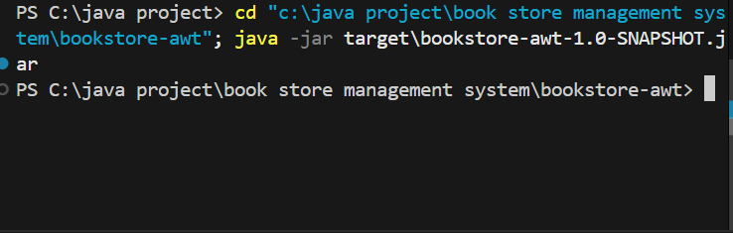

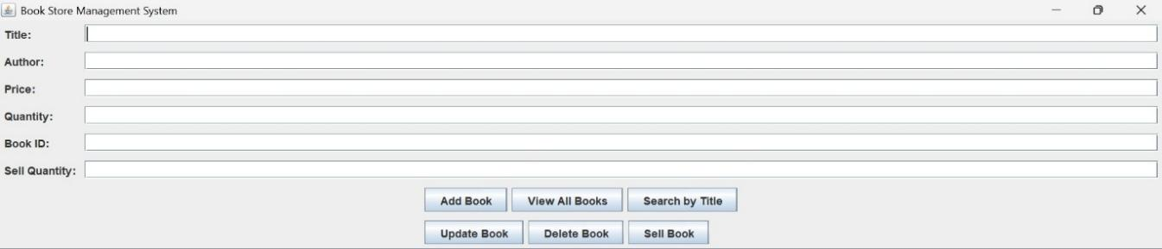

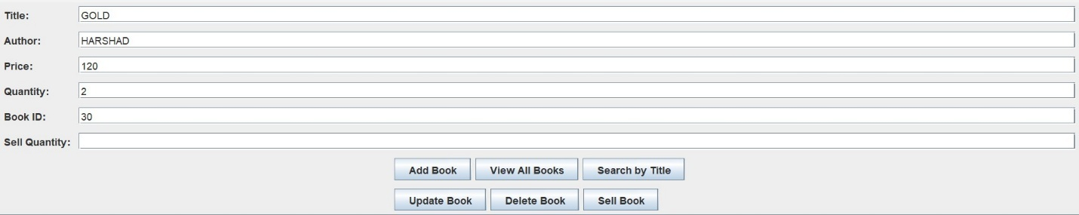

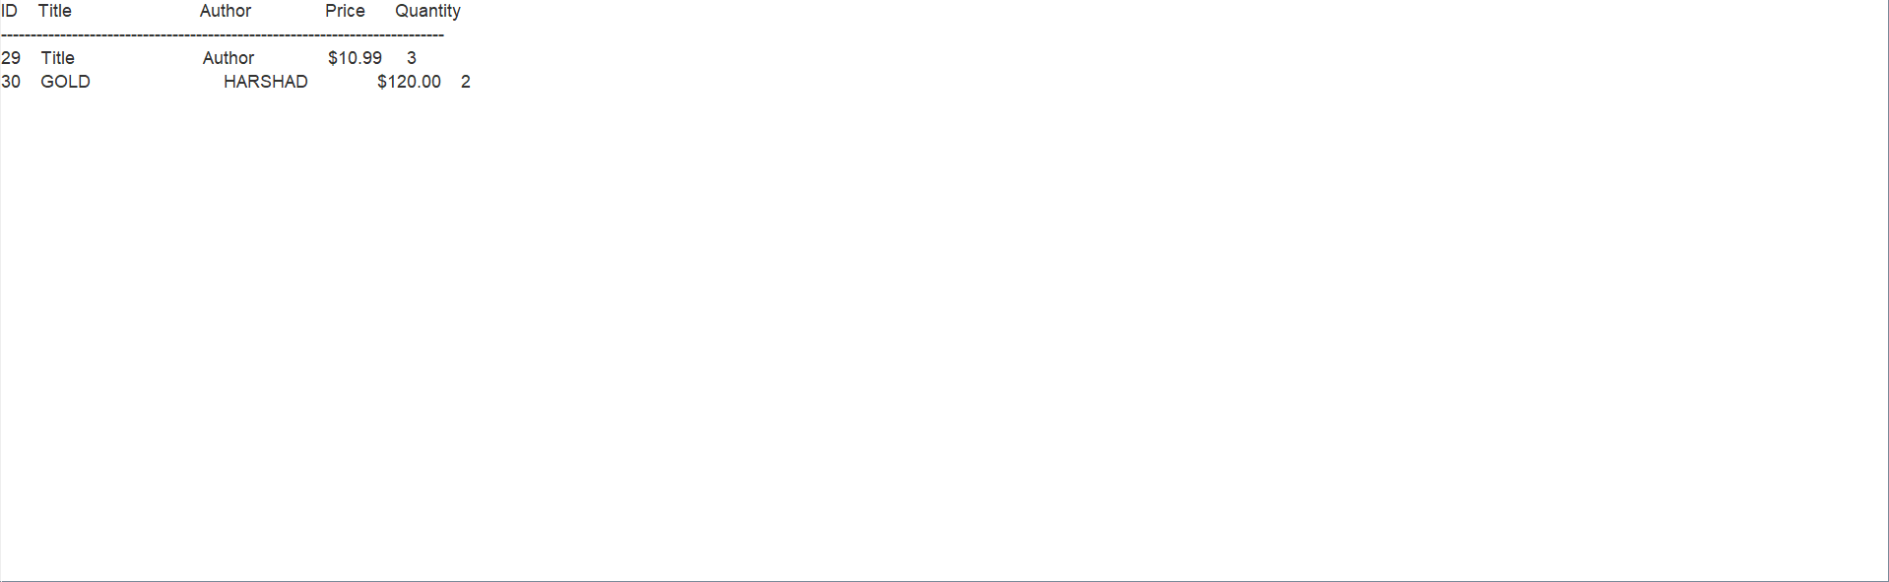

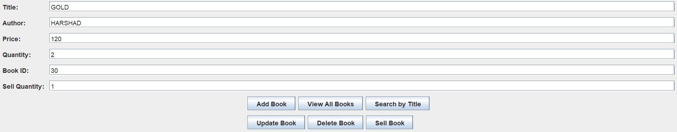

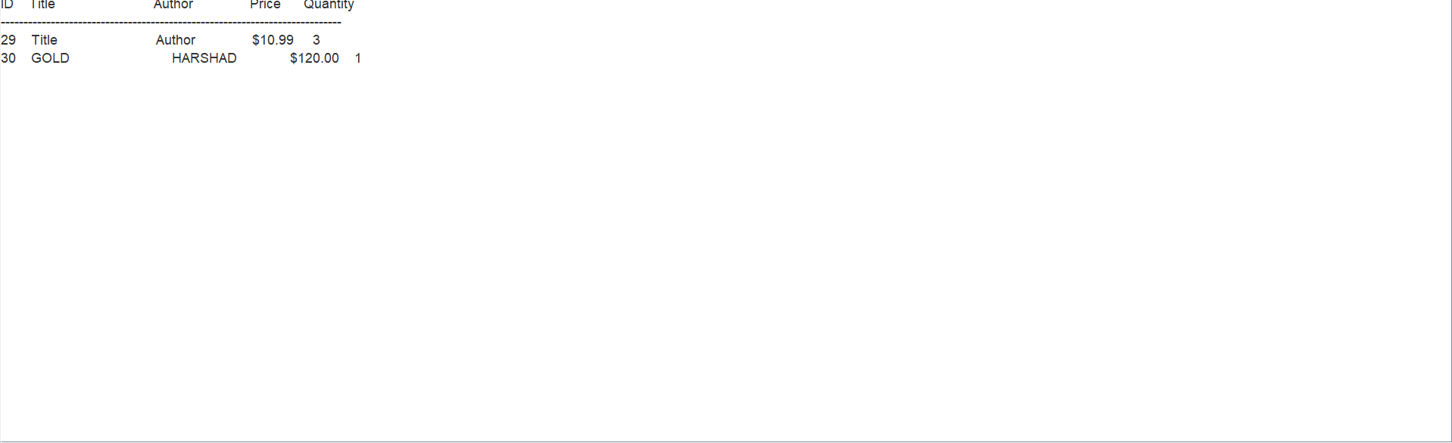

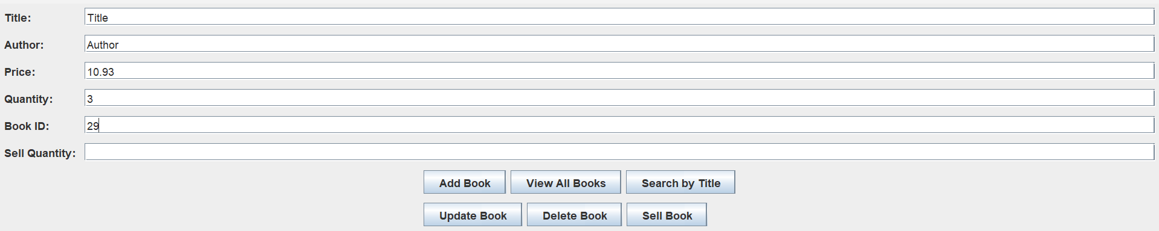



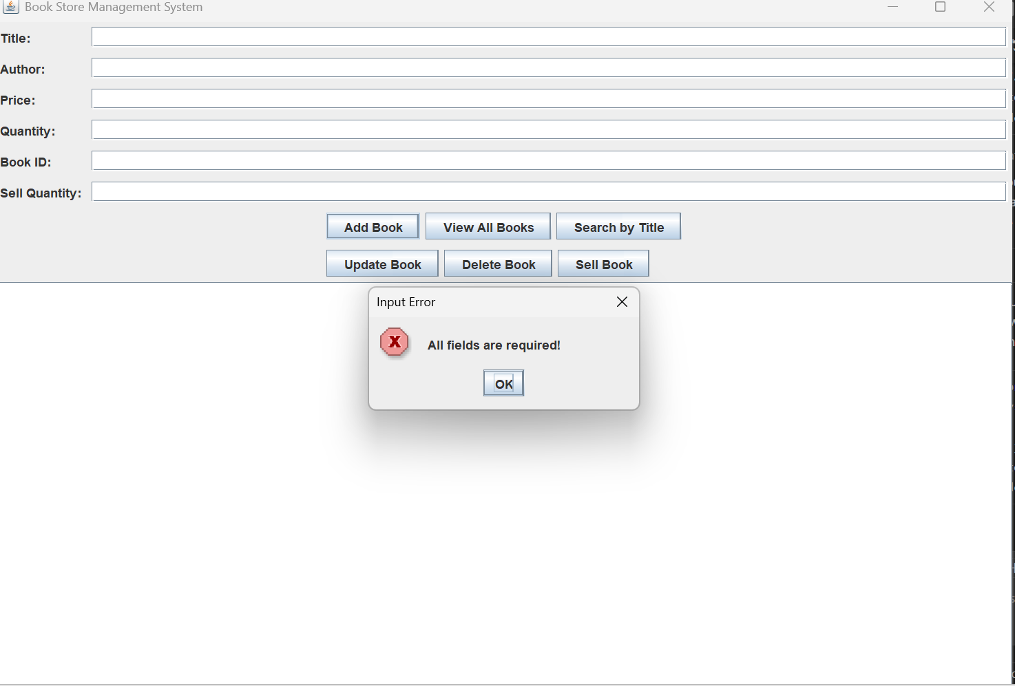

RESULT:

The Book Store Management System developed using Java AWT has been successfully implemented and tested. The login and registration modules function effectively, allowing users to create new accounts and securely log into the system. The application provides a simple and user-friendly interface, ensuring smooth navigation and clear feedback for every action performed. Through this implementation, the project achieves its goal of providing secure authentication and basic user management features, forming a solid foundation for future enhancements such as book inventory management, sales tracking, and report generation. Overall, the system performs as expected and demonstrates efficient handling of user data and interface design using AWT components.

